**Viral Violinist Lindsey Stirling returns with her Snow Waltz Christmas Tour 2024 Stylishly Blending Sonics and Visuals**

**The 21-date Trek Brings Her to Toronto, Las Vegas, Memphis, and More**

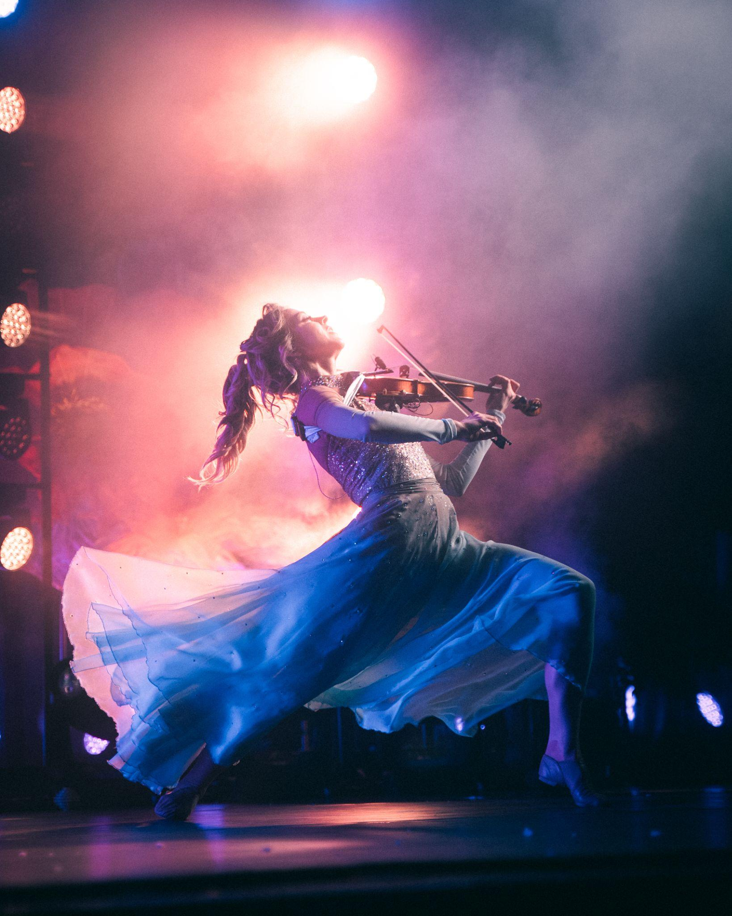

September 3, 2024: **Lindsey Stirling**, viral premier electronic violinist, dancer, and aerialist, is tuning up her bow for the holidays. The multi-platinum-selling musician-composer is ready to embark on her **North American Snow Waltz Tour 2024**, a 21-date trek that brings her to Toronto, Saint Louis, Las Vegas, Memphis, Lexington, and many more. Tickets for The Snow Waltz Tour 2024 go on sale Friday, September 6th, at 10 a.m. local times - tickets [**HERE**](https://www.lindseystirling.com/tour). VIP will be available at 10AM local time [**HERE**](https://preview.convertkit-mail2.com/click/dpheh0hzhm/aHR0cHM6Ly9saW5kc2V5c3Rpcmxpbmd2aXAuY29tL2NocmlzdG1hcw==). VIP includes great experiences including front row seating, a meet & greet, some new merch and an invitation to a pre-show experience, Ice Storm. There, fans can check out a Christmas gallery featuring costumes and memorabilia curated by Lindsey, a special "Sleigh Ride" photo opp, and so much more.

The tour, which gets its name from Stirling’s 2022 chart-topping *Snow Waltz* album, promises to be theatrical, eclectic, high-energy, and at least a little bit whimsical. Stirling mixes dance and acrobatics into her unique interpretations of holiday staples such as “Sleigh Ride,” “Joy to the World,” and “Deck the Halls” plus a few originals. Her concert performances take their cues from the 14-track *Snow Waltz*, which isn’t your everyday Christmas album.

“I put a little bit of spookiness into it,” she said during an appearance on The Kelly Clarkson Show. “I’m a big fan of *The Nightmare Before Christmas* as well as *Harry Potter*, which I feel like marries a little bit of that magic and spooky.”

That is quintessential Stirling, an artist who stylishly blends sonics with visuals – from her arresting mixture of pop, classical, hip-hop and electronica, to her meticulous attention to impactful, thematic album and video artwork. Artistically, she defies categorization. You can easily find her studio efforts at the top of Billboard’s Classical Albums chart, the Top Dance Electronic Album chart, and the all-genre Billboard 200 list. She is the rare artist, especially in the new millennium, to have amassed instrumental AC radio hits, particularly from her pair of Christmas albums – “Dance of the Sugar Plum Fairy” and “Carol of the Bells” from *Warmer in the Winter. “*Carol of the Bells” was the first instrumental to chart in the top 5 at radio. Additional notable songs include “Joy to the World” and “Sleigh Ride” from *Snow Waltz*.

Her latest studio release, 2024’s *Duality*, is yet another experimental opus that embraces Stirling’s indie music spirit, featuring guests such as Royal & the Serpent and Walk Off the Earth. Stirling makes brilliant use of *Duality*’s extravagant soundscape by exploring intricate questions of intuition and truth. “Eye Of The Untold Her” was used in Suni Lee’s gold & bronze medal winning floor routines during the Paris summer Olympics.

Stirling stays on the pulse of social media as well, amassing 14+ million subscribers and nearly three billion views on YouTube, over four million followers on Tik Tok, and 3.8+ on Instagram. It’s no wonder that Forbes placed her at #4 on its 2015 World’s Top-Earning YouTube Stars list. In a career spanning more than a decade, Stirling has sold more than 1 million headlining concert tickets. She also sold over 15,000 digital tickets for her live-streamed Christmas special in 2021, which was seen by more than 100,000 fans. 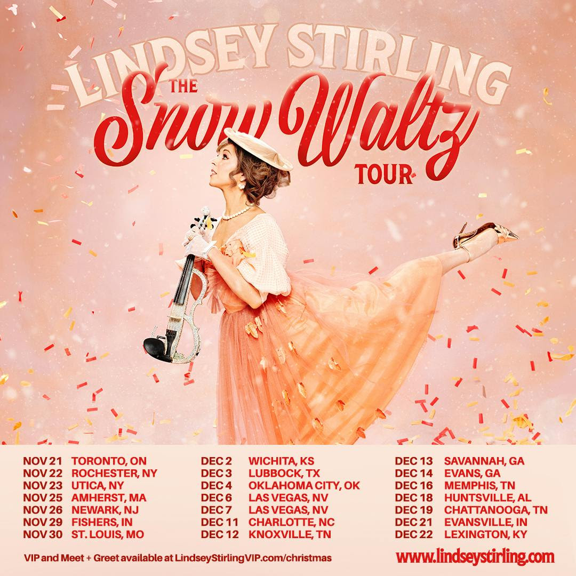

**Lindsey Stirling Snow Waltz Tour 2024 Dates**  
Thursday, November 21st – Toronto, ON – Meridian Hall  
Friday, November 22nd – Rochester, NY – Kodak Center Main Theater  
Saturday, November 23rd – Utica, NY – Stanley Theatre  
Monday, November 25th – Amherst, MA – Mullins Center-U. Mass at Amherst  
Tuesday, November 26th – Newark, NJ – NJPAC  
Friday, November 29th – Fishers, IN – Fishers Event Center  
Saturday, November 30th – Saint Louis, MO – Chaifetz Arena  
Monday, December 2nd – Wichita, KS – Century II Performing Arts - Concert Hall  
Tuesday, December 3rd – Lubbock, TX – The Buddy Holly Hall  
Wednesday, December 4th – Oklahoma City, OK – Paycom Center  
Friday, December 6th – Las Vegas, NV – The Venetian Theatre  
Saturday, December 7th, Las Vegas, NV – The Venetian Theatre  
Wednesday, December 11th – Charlotte, NC – Ovens Auditorium  
Thursday, December 12th – Knoxville, TN – Tennessee Theatre  
Friday, December 13th – Savannah, GA – Johnny Mercer Theatre  
Saturday, December 14th – Evans, GA – Columbia County Performing Arts Center  
Monday, December 16th – Memphis, TN – The Cannon Center for the Performing Arts  
Wednesday, December 18th – Huntsville, AL – VBC - Mark C. Smith Concert Hall   
Thursday, December 19th – Chattanooga, TN – Soldiers and Sailors Memorial Auditorium  
Saturday, December 21st – Evansville, IN – Old National Events Plaza  
Sunday, December 22nd – Lexington, KY – Rupp Arena