Subject: KK'S PRIEST and ACCEPT Announce 2024 North American Tour

Preview Text: Beginning August 31 in Los Angeles, CA | New Albums Out Now via Napalm Records!

–

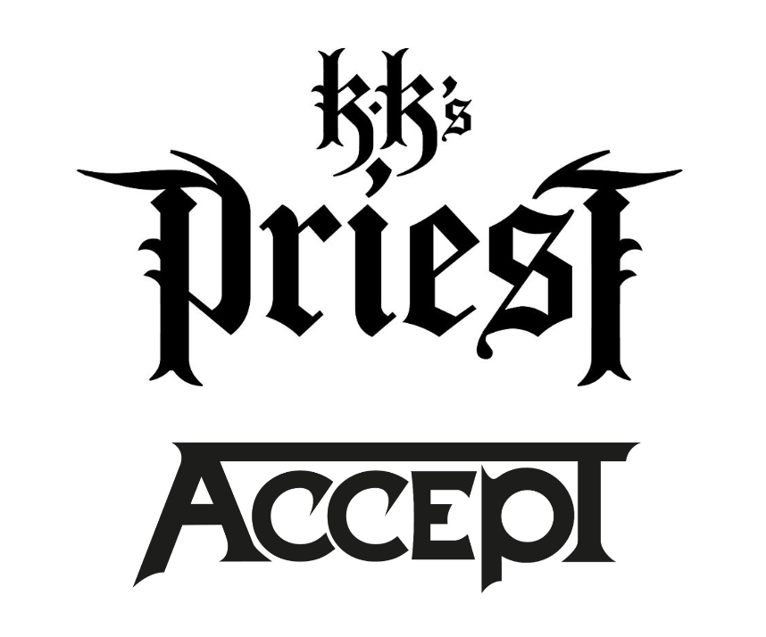

**KK'S PRIEST and ACCEPT**

**Announce 2024 North American Tour Dates**

**Beginning August 31 in Los Angeles, CA**

**Tickets On Sale Thursday, May 9**

**Order KK'S PRIEST's New Album, *The Sinner Rides Again*,** [**HERE**](https://lnk.to/KKsPriest-TheSinnerRidesAgain/napalmrecords)

**Order ACCEPT's New Album, *Humanoid*,** [**HERE**](https://lnk.to/ACCEPT-Humanoid/napalmrecords)

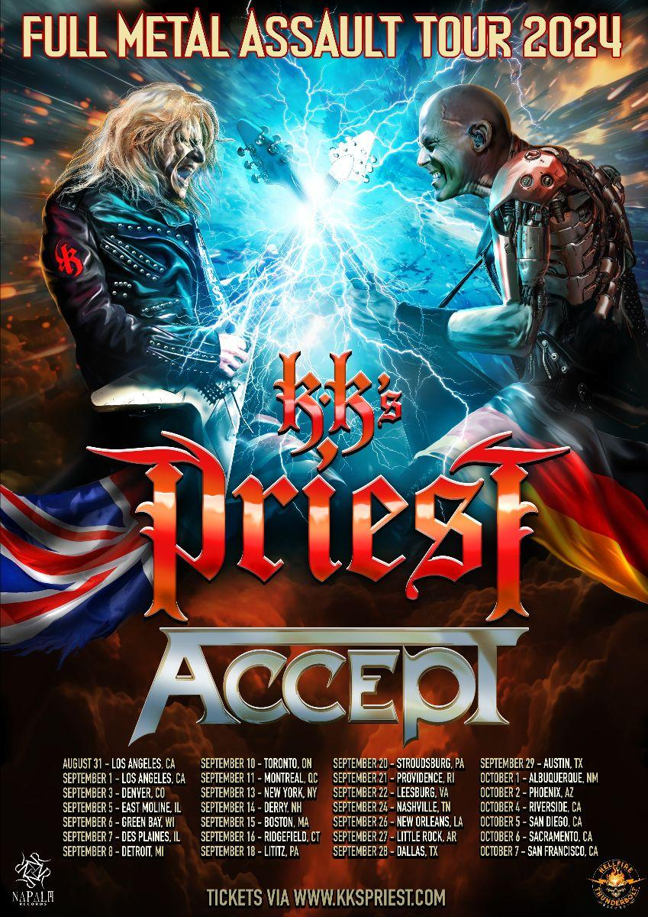

Heavy metal fans, prepare for the most electrifying tour of the year! Heavy metal frontrunners **KK’S PRIEST** - featuring **Judas Priest** alum and GRAMMY Award winning/nominated musicians K.K. Downing (guitar) and Tim “Ripper” Owens (vocals) - and Teutonic metal originators **ACCEPT** will join forces this fall 2024 for an unmissable North American tour! Both bands are touring in support of their brand new albums, out now via Napalm Records.

The massive run will begin on August 31 in Los Angeles, CA, visiting a slew of major cities in the USA and Canada - such as Toronto, ON, Montreal, QC, New York, NY and Nashville, TN - before coming to an end in San Francisco, CA on October 7. Tickets go on sale this Thursday, May 9 at 10:00am EDT, so get your tickets quickly before it's too late - these will go fast!

**KK's PRIEST's K.K. Downing says:**

*"It's time!!! Let the full European metal assault commence, KK's Priest / Accept. Not since 1983 have we shared the same battleground. From Germany, from the UK, let the Flying Vs clash, let the metal fly! All in the name of defending our beloved heavy metal music, let the people come from all walks of life to witness the battle royal. There is no doubt that we warriors of metal will give every ounce of our energy and our power in order to deliver up our very finest performance. This is a spectacle not to be missed, and this is possibly the one and only time in history for you to witness this iconic duel. Who will be the victor? You will be the judge, let the music begin from early August to early October... The arena awaits!!"*

**ACCEPT's Wolf Hoffmann says:**

*"“This tour with KK’s Priest is a dream come true for Accept and for me personally.*

*Accept supported Judas Priest back in the early 80s - it was our first ‘real’ international tour and Priest had been a huge influence on us.*

*I’m really looking forward to reconnecting with KK on this very special tour. It’s going to be epic! Don’t miss it!"*

**KK'S PRIEST & ACCEPT**

**Full Metal Assault Tour 2024**

August 31 - Los Angeles, CA - Whisky A Go-Go

September 1 - Los Angeles, CA - The Rainbow Backyard Bash 2024

September 3 - Denver, CO - Oriental Theater

September 5 - East Moline, IL - The Rust Belt

September 6 - Green Bay, WI - Epic Events Center

September 7 - Des Plaines, IL - Des Plaines Theater

September 8 - Detroit, MI - District 142

September 10 - Toronto, ON - QET

September 11 - Montreal, QC - Rialto Theatre

September 13 - New York, NY - The Palladium

September 14 - Derry, NH - Tupelo Music Hall

September 15 - Boston, MA - The Wilbur Theatre

September 16 - Ridgefield, CT - Ridgefield Playhouse

September 18 - Lititz, PA - Mickey's Black Box

September 20 - Stroudsburg, PA - Sherman Theater

September 21 - Providence, RI - The Strand Ballroom

September 22 - Leesburg, VA - Tally Ho Theater

September 24 - Nashville, TN - Brooklyn Bowl

September 26 - New Orleans, LA - The Fillmore

September 27 - Little Rock, AR - The Hall

September 28 - Dallas, TX - Tannahill's

September 29 - Austin, TX - Paramount Theatre

October 1 - Albuquerque, NM - Sunshine Theatre

October 2 - Phoenix, AZ - Celebrity Theatre

October 4 - Riverside, CA - Fox Performing Arts Center

October 5 - San Diego, CA - The Magnolia

October 6 - Sacramento, CA - Ace Of Spades

October 7 - San Francisco, CA - The Regency Ballroom

**KK'S PRIEST**

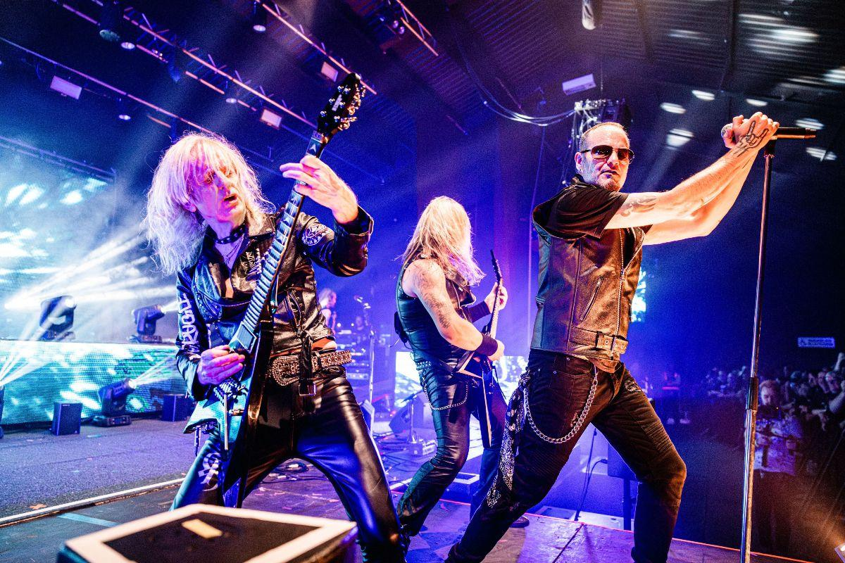

*[Photo Credit: Sam Singer]*

This past September, **KK’S PRIEST** unveiled their blistering sophomore offering, ***The Sinner Rides Again***, to rave reviews! *Blabbermouth* dubbed it *"an absolutely ripping metal record"*, while *Paste* stated, *"…with all respect to Rob Halford and co., nothing they’ve produced in recent years feels as dynamic and as heavy as the material that their former guitarist has been forging with his project* ***KK’S PRIEST****."* The album debuted at #1 on the US Hard Music Albums chart, #3 on the Top New Artist Albums chart and #6 on the Current Rock Albums chart. ***The Sinner Rides Again*** also landed at #6 on the end of year NACC Heavy radio chart, while resulting as one of the top spun albums of the year at Metal Contraband.

With ***The Sinner Rides Again***, **KK’S PRIEST** double down on the ripping melodic force of their debut, ***Sermons Of The Sinner*** - which *Metal Hammer UK* dubbed *“hugely enjoyable”* and *Metal Injection* cited as boasting *“catchy hooks and plenty of guitar wizardry”*. ***The Sinner Rides Again*** wields nine tracks of pure hellfire, produced and written by Downing and mixed/mastered by Jacob Hansen. The celebrated new album is a call for the classics while speeding full force into the future, delivered by some of heavy metal’s most essential performers.

**KK'S PRIEST is:**

Tim "Ripper" Owens - Vocals

K.K. Downing - Guitar

A.J. Mills - Guitar

Tony Newton - Bass

Sean Elg - Drums

**KK'S PRIEST online:**

[**WEBSITE**](http://www.kkspriest.com/)

[**FACEBOOK**](https://www.facebook.com/KKsPriest)

[**INSTAGRAM**](https://www.instagram.com/KKsPriest/)

[**NAPALM RECORDS**](https://label.napalmrecords.com/kks-priest)

**Order the New Album, *The Sinner Rides Again*,** [**HERE**](https://lnk.to/KKsPriest-TheSinnerRidesAgain/napalmrecords)

**Watch the music video for KK's PRIEST's**

***"One More Shot At Glory"*** [**HERE**](https://youtu.be/Sypj3SPBKKU?si=nkT42WEPRp4imG2E)**:**

[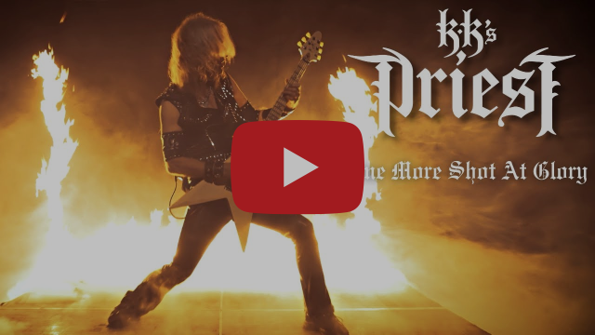](https://youtu.be/Sypj3SPBKKU?si=nkT42WEPRp4imG2E)

**ACCEPT**

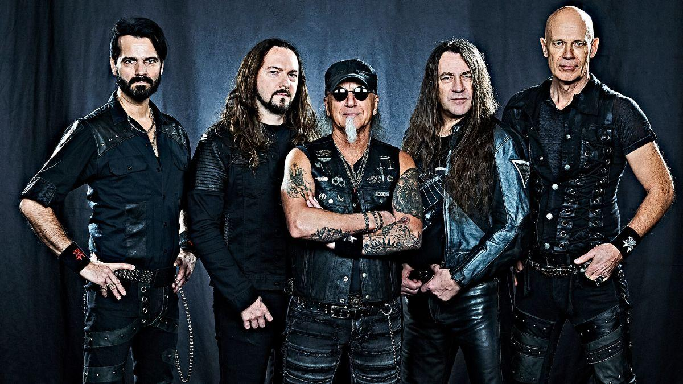

*[Photo Credit: Christoph Vohler]*

**ACCEPT** just released their latest full-length, ***Humanoid***, on April 26, 2024, proving that even after over 40 years, they remain a leading force in the worldwide heavy metal scene. *Metal Hammer* dubbed the album *"a new career peak"*, while *Angry Metal Guy* calls it *"another successful chapter in the second stage of Accept’s eternal crusade".* Marking yet another benchmark for the German heavy metal legends, ***Humanoid*** just debuted at #3 on the US Current Hard Music Albums chart, #2 on the Canadian Hard Music Albums chart and #1 on the NACC Heavy radio chart.

Once again finalized by leading metal producer Andy Sneap (Judas Priest, Amon Amarth, Testament, Saxon, etc.) at his Backstage Recording Studios Ltd. in Derbyshire, UK, ***Humanoid*** is a towering musical achievement and another world class entry in the **ACCEPT** catalog, certain to rally fans from around the world. ***Humanoid*** joins absolute genre classics like ***Balls To The Wall***, certified Gold in USA and Canada, ***Metal Heart***, and newer masterpieces like ***Blood of the Nations*** and the #1 charting album ***Blind Rage***. Their albums regularly place in national Top 10 sales charts, with global sales in excess of 17 million to date.

**ACCEPT is:**

Wolf Hoffmann – guitar

Mark Tornillo – vocals

Uwe Lulis – guitar

Martin Motnik – bass

Christopher Williams – drums

**ACCEPT online:**

[**THE INTERACTIVE HUMANOID EXPERIENCE**](https://accept-humanoid.vercel.app/)

[**HOMEPAGE**](https://www.acceptworldwide.com/)

[**FACEBOOK**](https://www.facebook.com/accepttheband/)

[**INSTAGRAM**](https://www.instagram.com/acceptworldwide/)[**X**](https://twitter.com/accepttheband)

[**VK**](https://vk.com/acceptofficial)

[**TIKTOK**](https://www.tiktok.com/@acceptofficial)

[**NAPALM RECORDS**](https://label.napalmrecords.com/accept)

**Order the New Album, *Humanoid*,** [**HERE**](https://lnk.to/ACCEPT-Humanoid/napalmrecords)

**Watch ACCEPT's recent video for *"The Reckoning"*** [**HERE**](https://youtu.be/yV8USmxRzw0?si=hRp0jtU_HMh0xTjj)**:**

[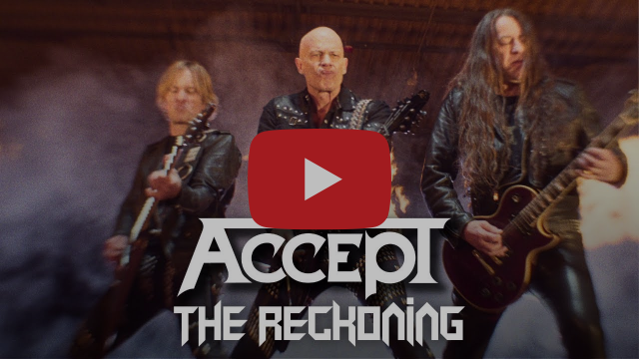](https://youtu.be/yV8USmxRzw0?si=hRp0jtU_HMh0xTjj)

**North American PR contacts:**

Natalie Camillo

Napalm Records

**natalie.camillo@napalmrecords.com**

Jon Freeman

Freeman Promotions

**freeman@freemanpromotions.com**