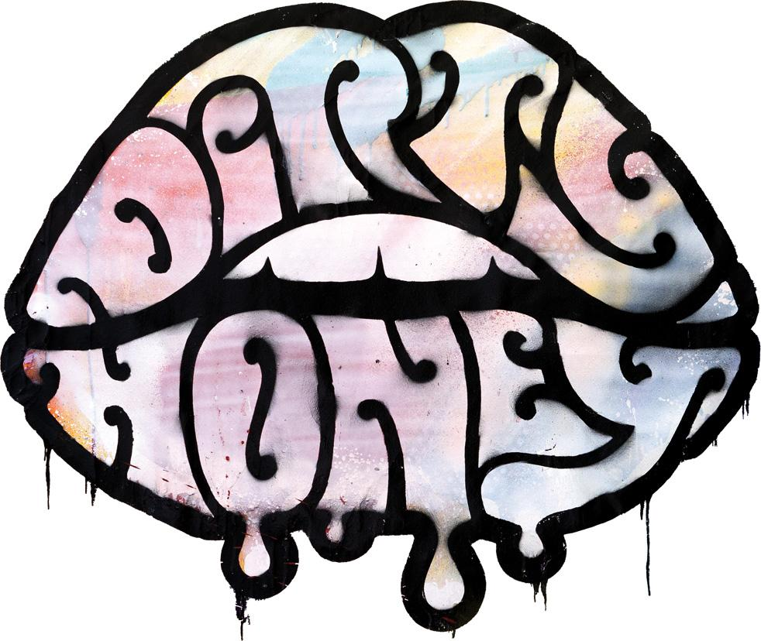

**DIRTY HONEY ANNOUNCES THE FINAL LEG**

**OF ITS “CAN’T FIND THE BRAKES WORLD TOUR"**

**33-Date North American Finale Launches on September 13**

**Ticket Pre-Sales Begin Tomorrow**

*"Blending classic rock riffs with Marc LaBelle’s searing vocals,*

*Dirty Honey have established themselves as one of the most exciting bands*

*of the past few years.”* – Nick Wells, Bass Player Magazine

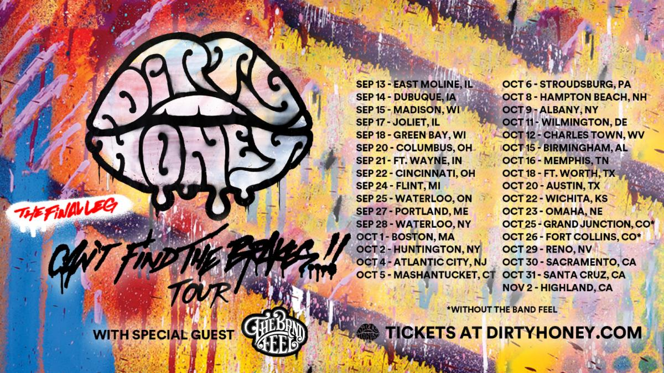

<https://spaces.hightail.com/space/ddul26yGCH>

TUESDAY, July 16, 2024 — With all three of its recent UK/European tours having completely sold out, and the band's first-ever Australian headline concerts also going clean, today Dirty Honey announces the final North American leg of their “California Dreaming World Tour." The dates begin on September 13 in Illinois, and will wrap on November 2 in Southern California. The complete itinerary is below. On most of these dates, the band - Marc LaBelle/vocals, John Notto/guitar, Justin Smolian/bass, and drummer Jaydon Bean - will welcome Special Guests, The Band Feel.

This tour announcement comes in tandem with Dirty Honey's new single, “Don’t Put Out The Fire,” coming in as the #1 Most Added Track at Active Rock Radio (Mediabase) in its debut week, followed by taking an incredible 59-point jump up the Active Rock Radio chart this week. Shot live in March at the band’s concert in Milano, Italy, you can check out the track’s music video [**HERE**](https://urldefense.com/v3/__https:/n8h7gggab.cc.rs6.net/tn.jsp?f=001zdniDnsYOwhGWcuGtmA2Y5BfdCv0xGfnWOXDwwUz_qHkPHvugl3uTiVs3VL1U7CTtU4ahu0qRpPPi67bzSdsXzP-QoXhcPmGcxDF8de1_t5V7Ylq1p0OJgTkaTYn0lrmjPQJjUHcOK5-f50UcjhKftcdBuDObYKnMG2WpQHOhXCbeVcn0CrRgg==&c=f_WkhQZEJgY9mUNDOWSiLEohkot8uKH1w0I2x8eFVYEDV2V77WROSQ==&ch=mvK4Ex1SpryJzJ6XLnfQHH4cQ69WBcJ6iyOS0I4fzKRJsXPMVde3XQ==__;!!F_iz1QV3Gc5jkBg!SQymkRYu52SghrrY4cAAscCrYvsv2tRbnRhmEmPLjFnQ_DLa0DxnM1b06ttfjnRvDA3wKU_8kxyuPbLPOJpqPRU0sEujWElyFmfD$).

Said the band’s vocalist Marc LaBelle, “After visiting fans all over the world, we’re really excited to announce the final leg of our 'Can’t Find the Brakes' tour where we’ll be hitting new corners of North America along with some cities we’ve grown very familiar with. As you can tell from our live videos, audiences from Milan to Sydney and everywhere in between have been thirsty for our brand of Rock N’ Roll and we’re more excited than ever to get face to face with our fans right here at home.”

For all ticketing information, log onto [**DirtyHoney.com**](https://urldefense.com/v3/__https:/n8h7gggab.cc.rs6.net/tn.jsp?f=001zdniDnsYOwhGWcuGtmA2Y5BfdCv0xGfnWOXDwwUz_qHkPHvugl3uTiVs3VL1U7CTF_yFLAY8u2jfHEuekHFsH8He87JyNZaQjM-5J4VnNKwK5EN-F1BTuO3v0SbBug2Qr_5j1LT-BbjesfP7636kEQ==&c=f_WkhQZEJgY9mUNDOWSiLEohkot8uKH1w0I2x8eFVYEDV2V77WROSQ==&ch=mvK4Ex1SpryJzJ6XLnfQHH4cQ69WBcJ6iyOS0I4fzKRJsXPMVde3XQ==__;!!F_iz1QV3Gc5jkBg!SQymkRYu52SghrrY4cAAscCrYvsv2tRbnRhmEmPLjFnQ_DLa0DxnM1b06ttfjnRvDA3wKU_8kxyuPbLPOJpqPRU0sEujWKtl1gnq$).

The complete itinerary for the final leg of Dirty Honey’s “Can’t Find The Brakes World Tour,” is as follows:

**SEPTEMBER**

13 The Rust Belt, East Moline, IL

14 Q Casino, Dubuque, IA

15 Majestic Theatre, Madison, WI

17 The Forge, Joliet, IL

18 EPIC Event Center, Green Bay, WI

20 The Bluestone, Columbus, OH

21 Piere’s, Ft. Wayne, IN

22 Bogart’s, Cincinnati, OH

24 The Machine Shop, Flint, MI

25 Maxwell’s, Waterloo, ON Canada

27 Aura, Portland, ME

28 Waterloo Casino, Del Lago, NY

**OCTOBER**

1 Big Night Live, Boston, MA

2 The Paramount, Huntington, NY

4 Sound Waves at Hard Rock, Atlantic City, NJ

5 The Great Cedar Showroom at Foxwoods Resort Casino, Mashantucket, CT

6 The Sherman Theatre, Stroudsburg, PA

8 Wally’s Hampton Beach, NH

9 Empire Live, Albany, NY

11 The Queen, Wilmington, DE

12 The Event Center at Hollywood Casino at Charles Town Races, Charles Town, WV

15 Iron City, Birmingham, AL

16 Minglewood Hall, Memphis, TN

18 Tannahill’s Tavern & Music Hall, Ft. Worth, TX

20 Scoot Inn, Austin, TX

22 Temple Live, Wichita, KS

23 The Admiral, Omaha, NE

25 Mesa Theater, Grand Junction, CO

26 Washington Foco, Fort Collins, CO

29 Virginia Street Brewhouse, Reno, NV

30 Ace of Spades, Sacramento, CA

31 The Catalyst, Santa Cruz, CA

**NOVEMBER**

2 Tukut Lounge - Yaamava' Casino - Rock N Brews Concert Series, Highland, CA

**ABOUT DIRTY HONEY**

The Los Angeles-based rock band Dirty Honey made music biz history when their 2019 debut single, “When I’m Gone,” went all the way to #1 on *Billboard’s* Mainstream Rock and Hard Rock charts, making Dirty Honey the first - and still only - totally independent, unsigned artist to achieve that. The band sold out its first two U.S. headline tours, *Rolling Stone* named them an “Artist You Need To Know,” their self-titled, debut album was released in April, 2021, and with no major label affiliation or support, entered the Current Hard Rock Album chart at #2. The band received rave reviews and standing ovations when they opened for The Black Crowes on that band’s nine-week, Summer 2021 "Shake Your MoneyMaker” U.S. amphitheatre tour, and averaged $15,000 a night in t-shirt/merch sales. Not bad for a then still developing, opening act.

Dirty Honey has toured the UK and Europe three times - first, in Summer 2022, playing support dates with Rival Sons, KISS, and Guns N’ Roses, plus a handful of first-time headline shows, all sold out, many of which had to be moved to larger venues due to ticket demand. In January 2023, they returned for their very first full headline tour there - 30 shows in 13 countries, all dates sold out. June/July 2023 saw them playing support shows with Guns N’ Roses and KISS, plus major festival appearances and headline dates - 21 shows in 12 countries - with all headline dates sold out.

**Connect with Dirty Honey here:** [https://www.dirtyhoney.com/](https://urldefense.com/v3/__https:/n8h7gggab.cc.rs6.net/tn.jsp?f=001zdniDnsYOwhGWcuGtmA2Y5BfdCv0xGfnWOXDwwUz_qHkPHvugl3uTmXtjRPSJPeK-gd3SmizC5mRS_3WUzQTsDJrX2fHsQac6LEwPumpIW7y741mKTa1cR8GiRP3dNly-9lfJzuUYWmjvl43MprNUZ5Do45_A899&c=f_WkhQZEJgY9mUNDOWSiLEohkot8uKH1w0I2x8eFVYEDV2V77WROSQ==&ch=mvK4Ex1SpryJzJ6XLnfQHH4cQ69WBcJ6iyOS0I4fzKRJsXPMVde3XQ==__;!!F_iz1QV3Gc5jkBg!SQymkRYu52SghrrY4cAAscCrYvsv2tRbnRhmEmPLjFnQ_DLa0DxnM1b06ttfjnRvDA3wKU_8kxyuPbLPOJpqPRU0sEujWO8tUdcX$)

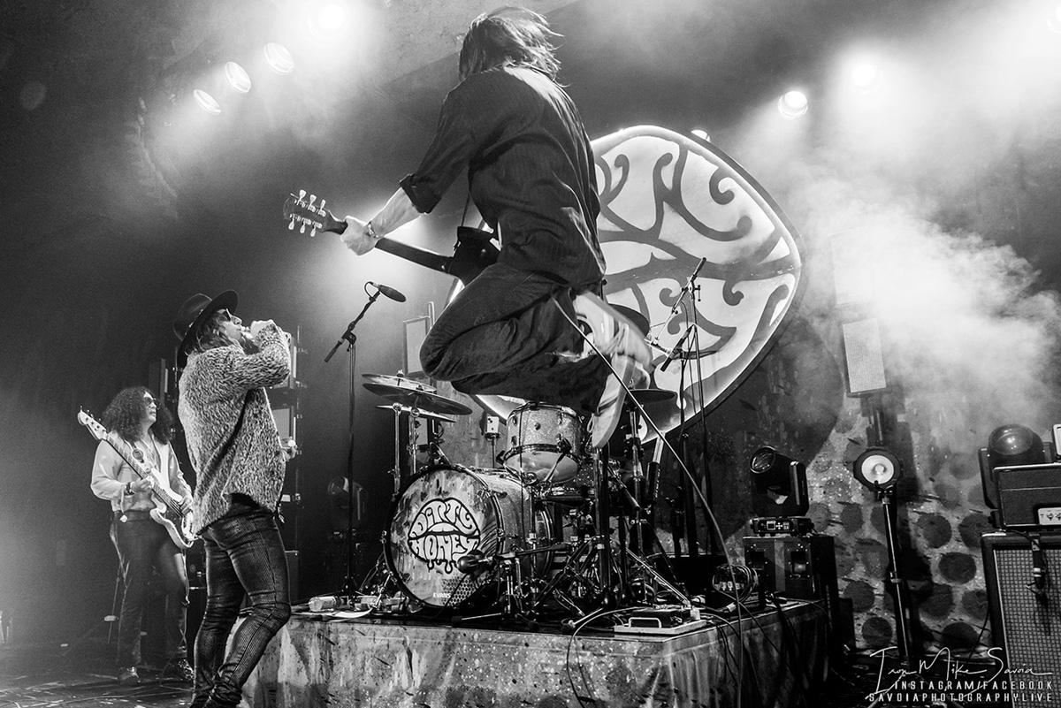

[[n8h7gggab.cc.rs6.net]](https://urldefense.com/v3/__https:/n8h7gggab.cc.rs6.net/tn.jsp?f=001zdniDnsYOwhGWcuGtmA2Y5BfdCv0xGfnWOXDwwUz_qHkPHvugl3uTiVs3VL1U7CTW6RB5F_dHqYe3zQxCJ5pf5FjEzbjGNXWjNOa9ebNESqC9E-FkDaS7Q5y-4I0aoEek5tLCAK-Im93d-lsaRRRDkTtrpbW1a4d1tmILHnzCc7Ff-N_6fNOxg==&c=f_WkhQZEJgY9mUNDOWSiLEohkot8uKH1w0I2x8eFVYEDV2V77WROSQ==&ch=mvK4Ex1SpryJzJ6XLnfQHH4cQ69WBcJ6iyOS0I4fzKRJsXPMVde3XQ==__;!!F_iz1QV3Gc5jkBg!SQymkRYu52SghrrY4cAAscCrYvsv2tRbnRhmEmPLjFnQ_DLa0DxnM1b06ttfjnRvDA3wKU_8kxyuPbLPOJpqPRU0sEujWNd14ECN$)

**Dirty Honey L-R:** Justin Smolian/bass; Marc LaBelle/vocals; John Notto/guitar;

Jaydon Bean/drums

**Photo credit:** Mike Savoia

**North American Contact:** Mitch Curley • mitch.curley@redlightmanagement.com